

SRI LANKA INSTITUTE OF INFORMATION TECHNOLOGY

[**Enterprise Standards and Best Practices for IT Infrastructure**](http://courseweb.sliit.lk/course/view.php?id=137)

**4th Year 2nd Semester 2014**

Name: L.A.C.Dissanayake.

SLIIT ID:IT13147006

Group Number:

Practical Session: WD

Practical Number : Lab 03

Date of Submission: 30/07/2016

Date of Evaluation : _____________________

Evaluators Signature : _____________________

Introduction

We launch a Multi-AZ DB instance. This means that Amazon RDS automatically provisions and maintains a synchronous standby replica in a different Availability Zone. Updates to your DB instance are synchronously replicated across Availability Zones to the standby in order to keep them in sync and protect your latest database updates against DB instance failure. During certain types of planned maintenance, or in the event of DB instance failure or Availability Zone failure, Amazon RDS automatically fails over to the standby. Because the name record for your DB instance remains the same

* Sign in to the AWS Management Console and open the Amazon RDS console at <https://console.aws.amazon.com/rds/>.

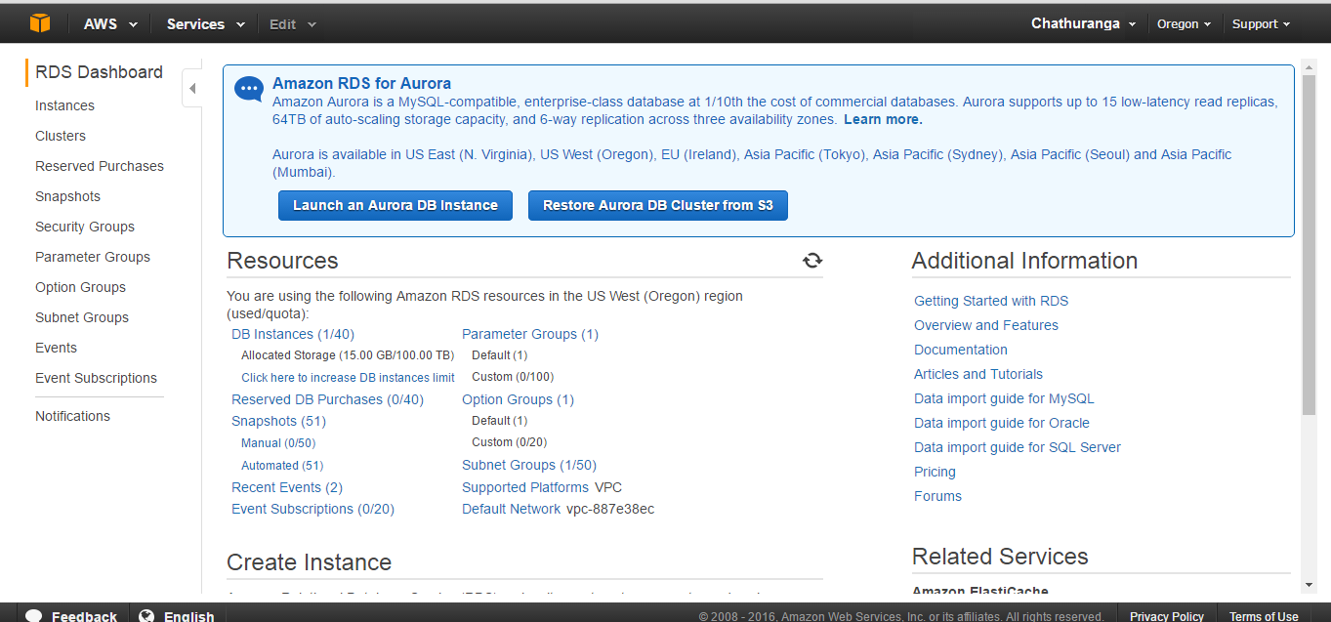

* In the top right corner of the AWS Management Console, select the region in which you want to create the DB instance. In the navigation pane, click **Instances**.

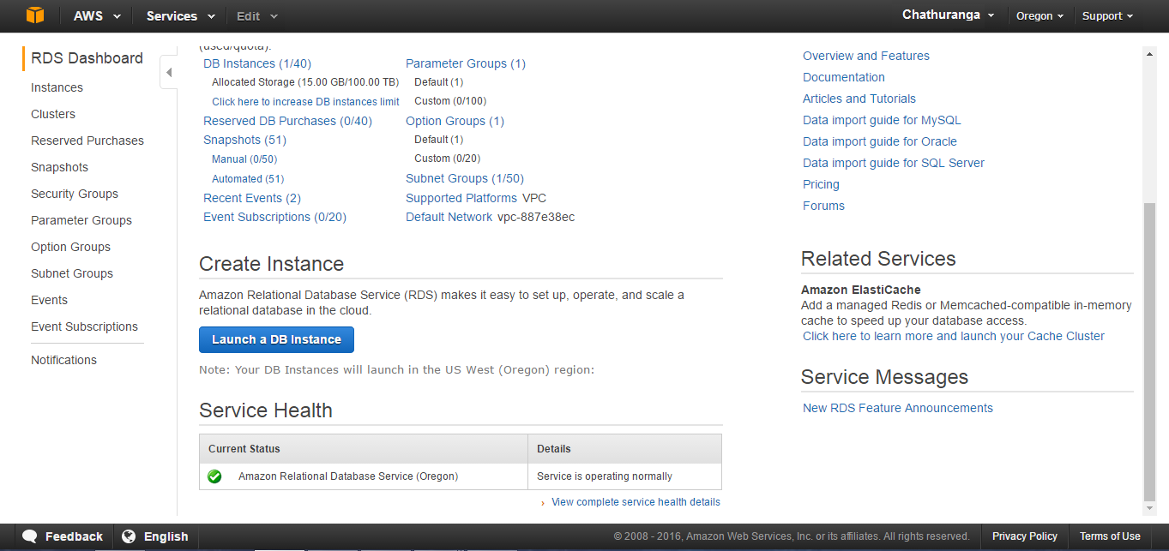

* Click **Launch DB Instance** to start the **Launch DB Instance Wizard**. The wizard opens on the **Select Engine** page. In the **Launch DB Instance Wizard** window, click the **Select** button for the MySQL DB engine.

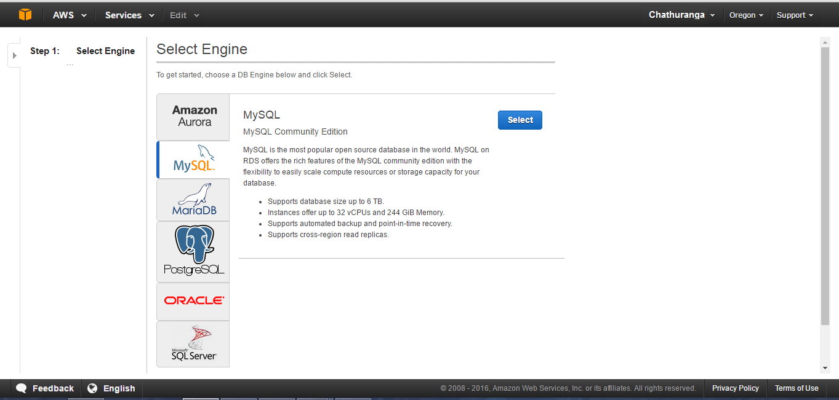

* Select **Yes**. By selecting **Yes**, the failover option **Multi-AZ** and the **Provisioned IOPS** storage option will be preselected in the following step. Click **Next** when you are finished.

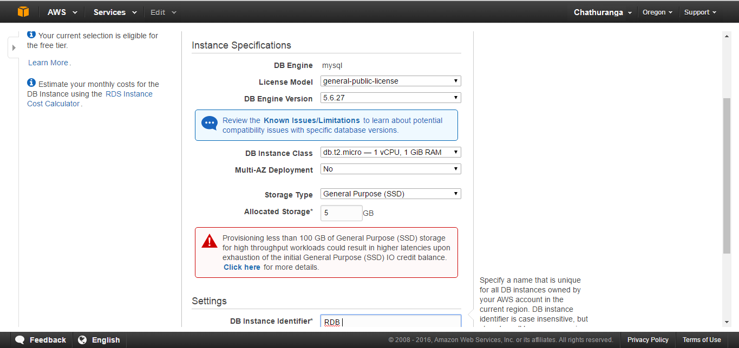

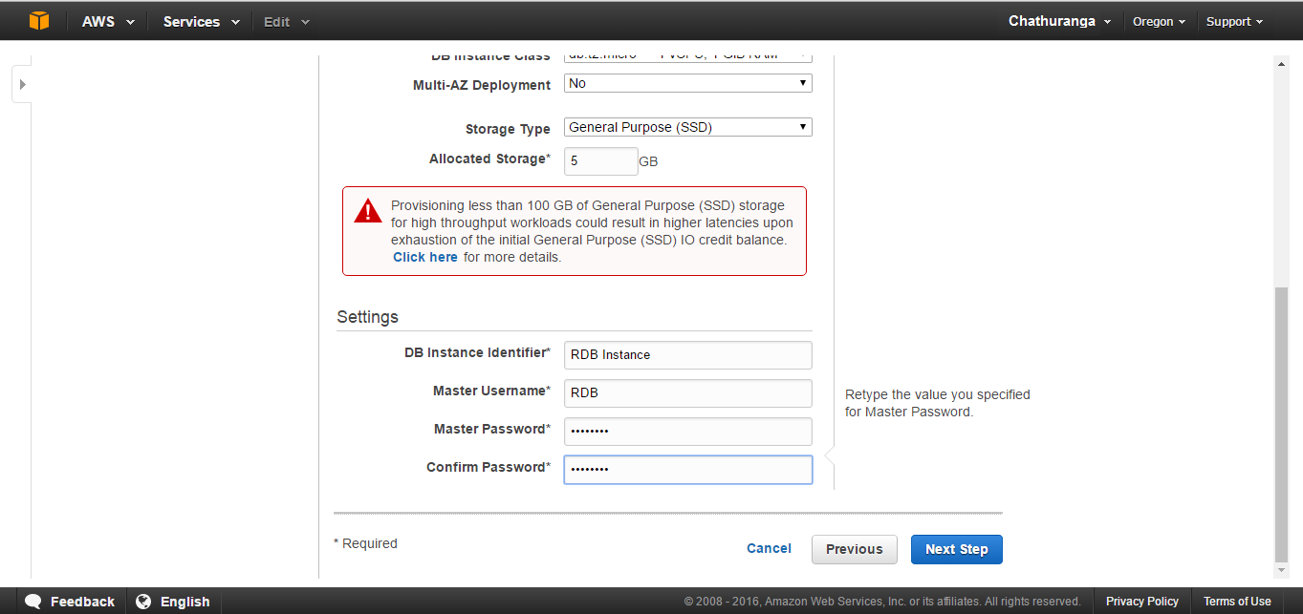

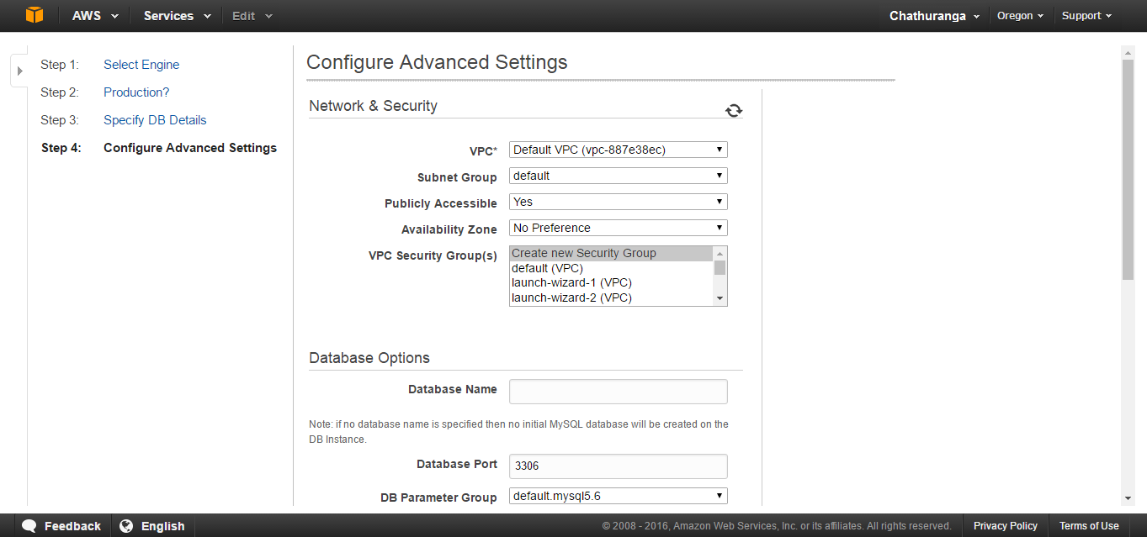

* Click **Launch DB Instance** to create your MySQL DB instance.
* On the final page of the wizard, click **Close**.

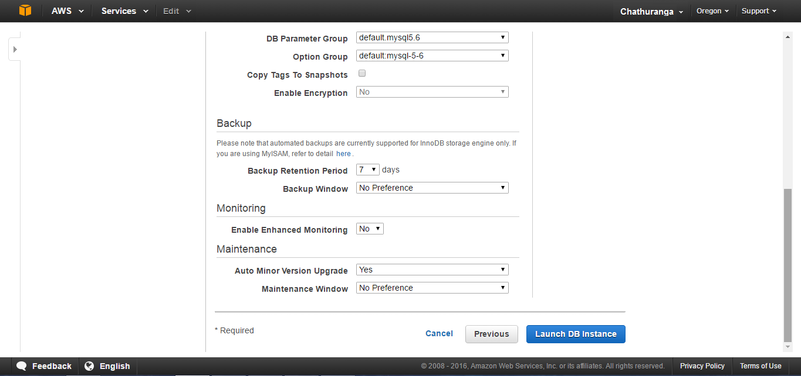

* The new DB instance appears in the list of DB instances. The DB instance will have a status of **creating** until the DB instance is created and ready for use. When the state changes to **available**, you can connect to the DB instance. Depending on the DB instance class and store allocated, it could take several minutes for the new instance to be available

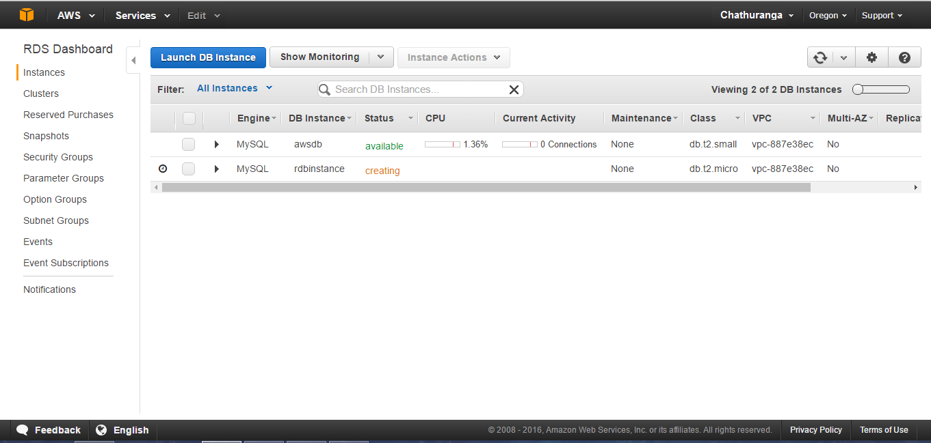

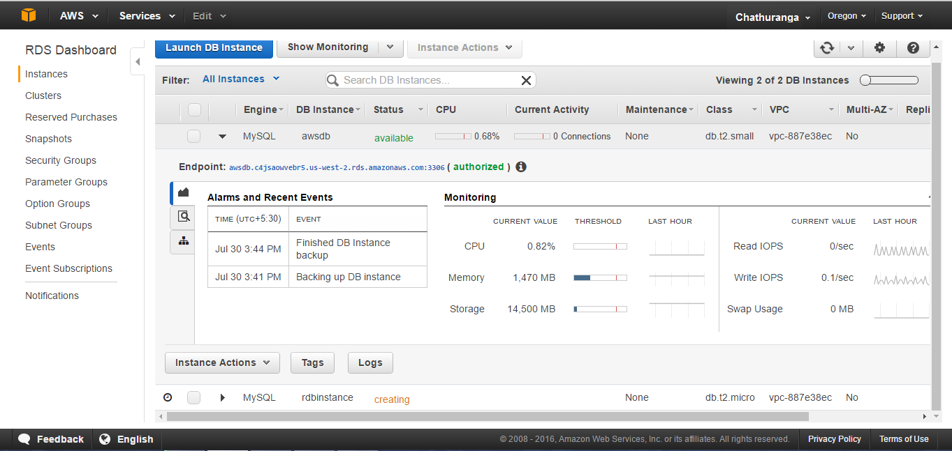

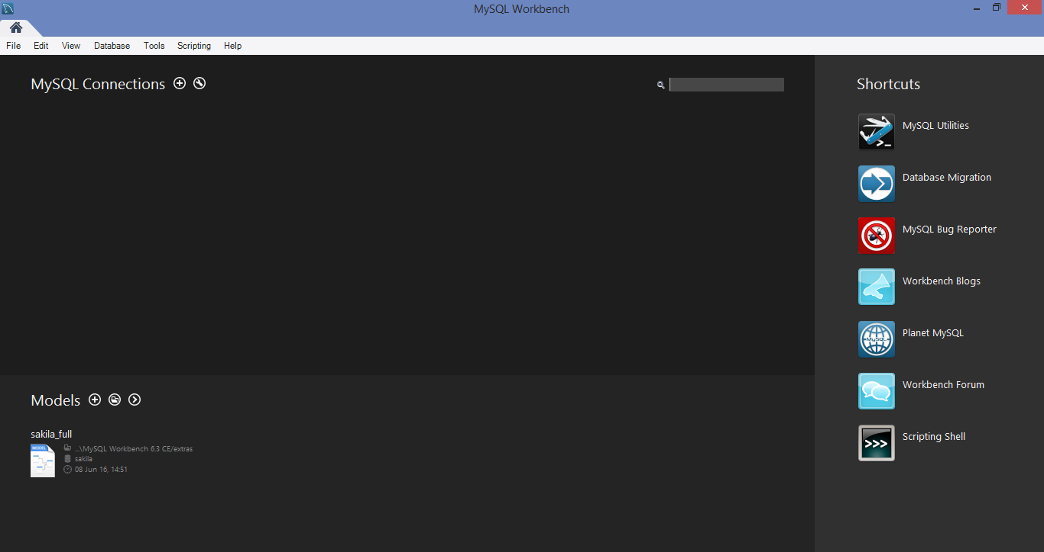

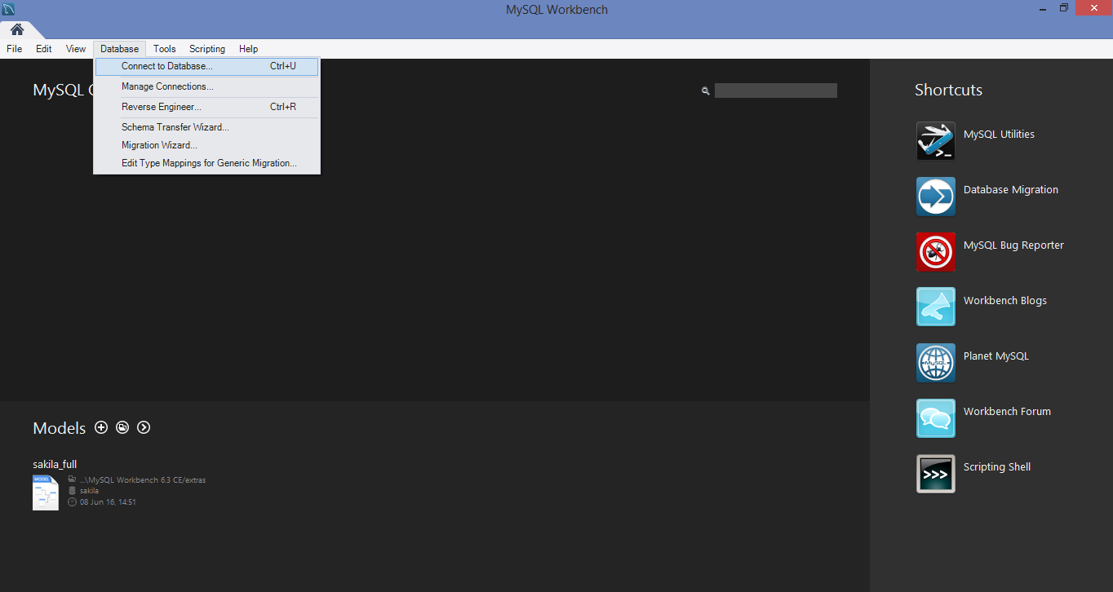

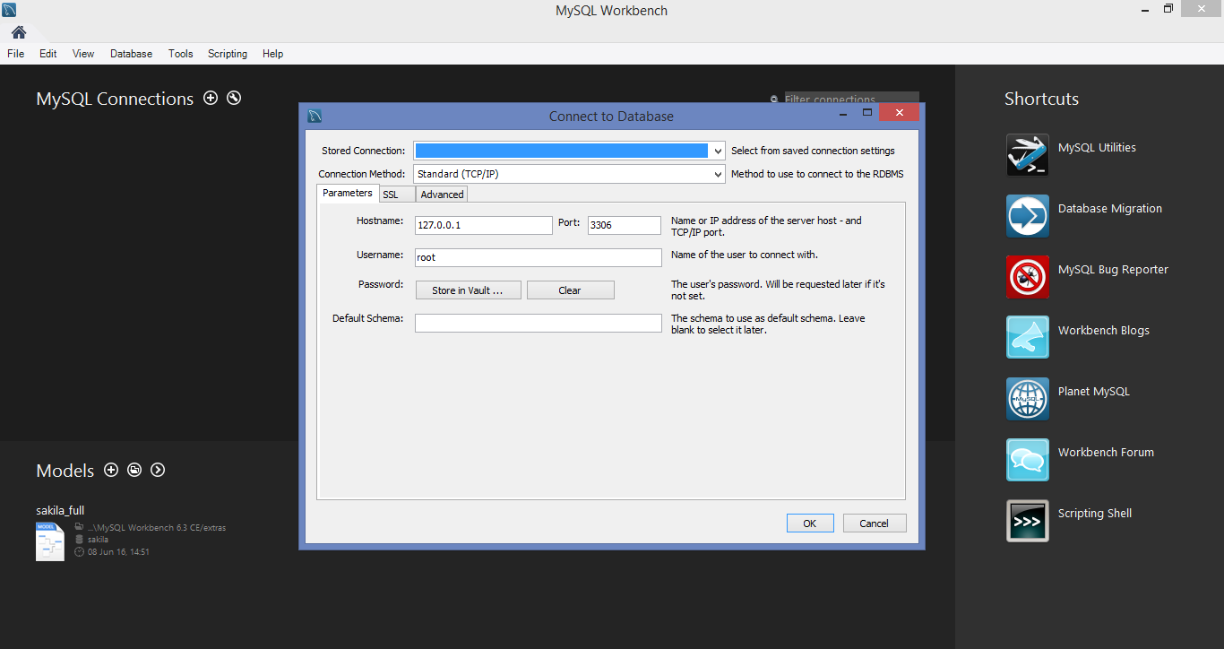

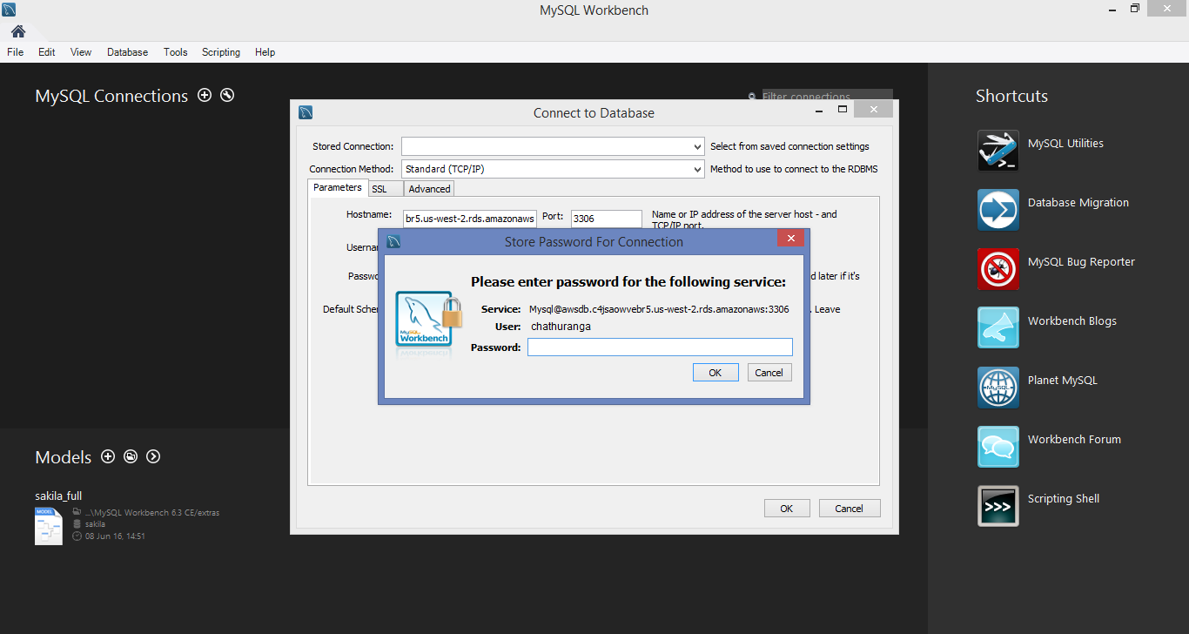

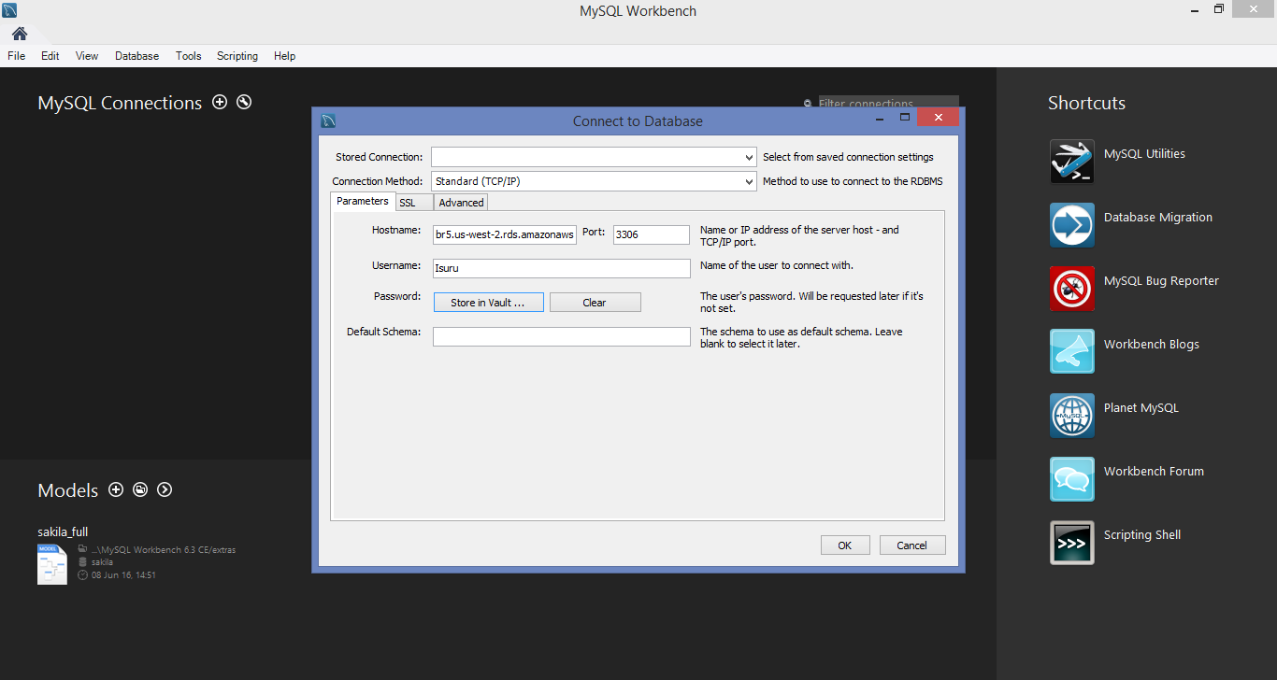

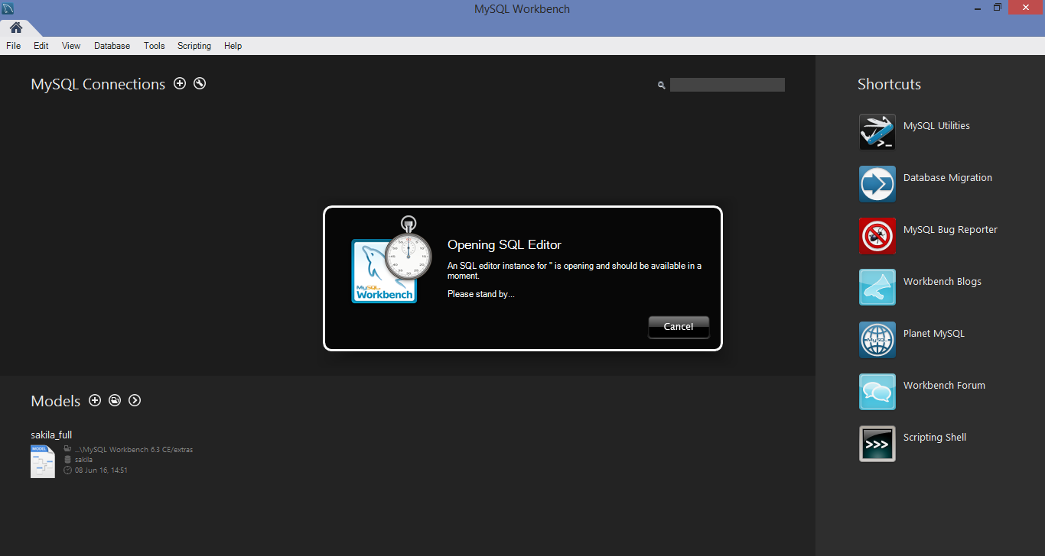

Referance

1. <https://console.aws.amazon.com/ec2/>
2. <http://docs.aws.amazon.com/AmazonRDS/latest/UserGuide/USER_CreateInstance.html>
3. http://docs.aws.amazon.com/gettingstarted/latest/wah-linux/getting-started-create-rds.html